Cold protection according to the application of the glove.

A number of factors must be considered when selecting a glove for protection against the cold, examples of these can be seen in Table B.1.
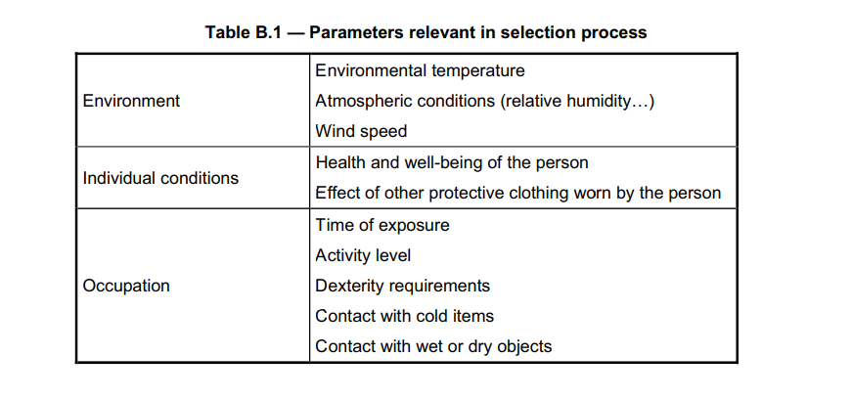
In has been shown in studies that some connections exist between these parameters and the level of thermal insulation required to protect in cold conditions. Annex B of EN 342:2004 provides a table which contains such information. Figure B.1 below shows the thermal insulation level required for three different activity levels with regards to ambient air temperature at a wind speed below 0,5 m/s (source: Goldman 1994).
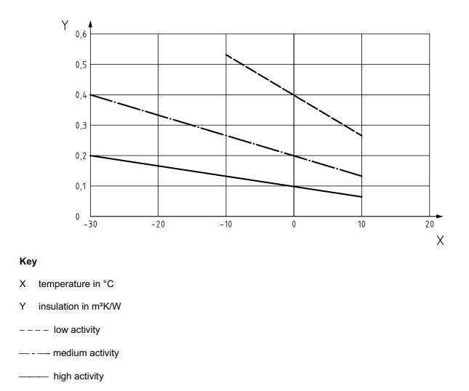
Figure B.1 – Glove insulation requirements at three levels of physical activity
NOTE The parameters considered in the study (air, velocity etc.) may not be the same as used in the convective cold test method referenced in 5.4.

